**[Plugin - Ach/Pet] Higher Learning Achievment !**

Hey guys, ITS DONE ! http://www.thebuddyforum.com/images/smilies/smile.png  
  
Thanks to the pro coding skillz of [**HighVoltz**](http://www.buddyforum.de/member.php?13973-highvoltz) the plugin is now running flawlessly.  
He created the whole plugin !  
  
Version 1.6 - Now working after months of downtime. Dalaran mesh is fixed + Blackspots. Thanks to katzerle for the tweaks.  
Version 1.5 - Removed books from Horde/Alliance areas + Delay Timer !!!  
Version 1.4 - Found another list of MORE Junk books that have been added !  
Version 1.3 - Now has ALL of the Junk books added !  
Version 1.2 - Now Blacklists read books for 5 minutes !  
  
To run this Plugin:  
  
**1. Move BookCollector1.3.cs to your plugin folder  
2. Start Honorbuddy  
3. Go to the plugins tab and make sure the box is ticked.  
4. Load the Profile.xml  
5. Stand anywhere in dalaran and press start.**  
  
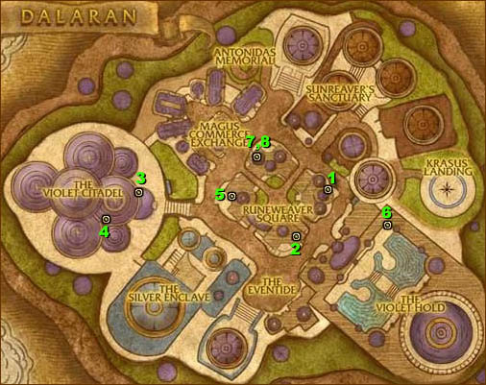  
  
Also special thanks to Ntsmarkv for the profile. There is currently a problem with the dalaran mesh so one of the books outside VH cannot be collected but hopefully we will find a solution to this soon.